Activity | Data Type
Number of beatings from Wife | Discrete
Results of rolling a dice | Discrete
Weight of a person | Continuous
Weight of Gold | Continuous
Distance between two places | Continuous
Length of a leaf | Continuous
Dog's weight | Continuous
Blue Color | Discrete
Number of kids | Discrete
Number of tickets in Indian railways | Discrete
Number of times married | Discrete
Gender (Male or Female) | Discrete
Q1) Identify the Data type for the Following:

Q2) Identify the Data types, which were among the following
Nominal, Ordinal, Interval, Ratio.
Data | Data Type
Gender | Discrete Data- nominal
High School Class Ranking | Discrete Data -nominal
Celsius Temperature | Continuous-Interval
Weight | Continuous-Ratio
Hair Color | Discrete-Ratio
Socioeconomic Status | Continuous-Interval
Fahrenheit Temperature | Continuous-Ratio
Height | Continuous-Ratio
Type of living accommodation | Discrete-ordinal
Level of Agreement | Discrete data-interval
IQ(Intelligence Scale) | Discrete data-interval
Sales Figures | Discrete data-interval
Blood Group | Discrete data-ratio
Time Of Day | Continuous-Interval
Time on a Clock with Hands | Continuous-Interval
Number of Children | Discrete data-interval
Religious Preference | Discrete ratio
Barometer Pressure | Discrete data-interval
SAT Scores | Discrete ratio
Years of Education | Discrete Data- nominal

Q3) Three Coins are tossed, find the probability that two heads and one tail are obtained?
Ans:P(H,H,T)+P(H,T,H)+P(T,H,H)
1/8+1/8+1/8=3/8
=3/8 (Binomial Distribution)

Q4) Two Dice are rolled, find the probability that sum is
- Equal to 1
- Less than or equal to 4
- Sum is divisible by 2 and 3
Ans: a)There is no outcomes which corresponds sum is equal to one=0/36. Probability is 0
b) (1,3) (2,2) (3,1) = 3 outcomes, 3/36 = 1/12
c) 6/36= 1/6

Q5) A bag contains 2 red, 3 green and 2 blue balls. Two balls are drawn at random. What is the probability that none of the balls drawn is blue?
Ans:red=2,green=3,blue=2
P(5/7,4/6)=20/42
=10/21

Q6) Calculate the Expected number of candies for a randomly selected child
Below are the probabilities of count of candies for children (ignoring the nature of the child-Generalized view)
CHILD | Candies count | Probability
A | 1 | 0.015
B | 4 | 0.20
C | 3 | 0.65
D | 5 | 0.005
E | 6 | 0.01
F | 2 | 0.120
Child A – probability of having 1 candy = 0.015.
Child B – probability of having 4 candies = 0.20
Ans: expected candy from randomly selected child=1*0.015+4*0.20+3*0.65+5*0.005+6*0.01+2*0.120
=0.015+0.8+1.95+0.025+0.06+0.24
=3.09

Q8) Calculate Expected Value for the problem below
- The weights (X) of patients at a clinic (in pounds), are
108, 110, 123, 134, 135, 145, 167, 187, 199
Assume one of the patients is chosen at random. What is the Expected Value of the Weight of that patient?
Ans: Expected Value = ∑ (probability*Value)
∑ P(x).E(x)
there are 9 patients
Probability of selecting each patient = 1/9
Ex 108, 110, 123, 134, 135, 145, 167, 187, 199
P(x) 1/9 1/9 1/9 1/9 1/9 1/9 1/9 1/ 9 1/9
Expected Value = (1/9) (108) + (1/9)110 + (1/9)123 + (1/9)134 + (1/9)135 +
(1/9)145 + (1/9(167) + (1/9)187 + (1/9)199
= (1/9) (108 + 110 + 123 + 134 + 135 + 145 + 167 + 187 + 199)
= (1/9) (1308)
= 145.33 Expected Value of the Weight of that patient = 145.
Q10) Draw inferences about the following boxplot & histogram

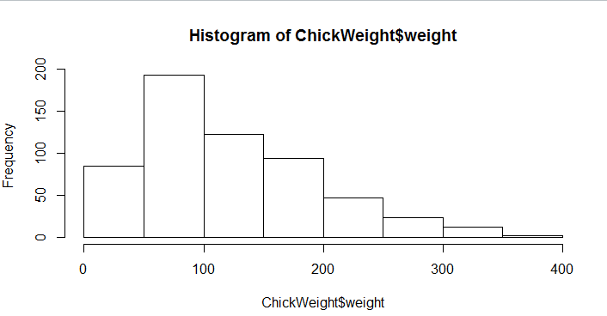
Ans: The most of the data points are concerated in the range 50-100 with frequency 200. And least range of weight is 400 somewere around 0-10.So the expected value the above distribution is 75.Skewness- we can notice a long tail towards right so it is heavily right skewed.

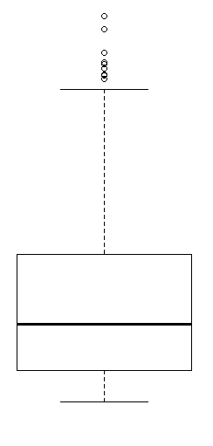
Ans:Medican is less than mean right skewed and we have outlier on the upperside of box plot and there is less data points between Q1 and bottom point.
Q13)What is the nature of skewness when mean, median of data are equal?
Ans: mean is equal to the median as well as the mode, hence the skewness is zero
Q14) What is the nature of skewness when mean > median ?
Ans: Skewness and tail is towards Right.
Q15) What is the nature of skewness when median > mean?
Ans: the distribution is positively skewed
Q16) What does positive kurtosis value indicates for a data ?
Ans: that a distribution is peaked and possess thick tails.
Q17) What does negative kurtosis value indicates for a data?
Ans: distribution is flat and has thin tails
Q18) Answer the below questions using the below boxplot visualization.
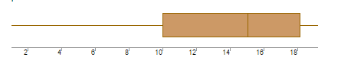
What can we say about the distribution of the data?
Ans : The data is distributed in De-assigned format

1.What is nature of skewness of the data?
Ans = Left side skewed
2.What will be the IQR of the data (approximately)?
Ans = Q3-Q1
= 18-10
= 8 is IQR

Q19) Comment on the below Boxplot visualizations?
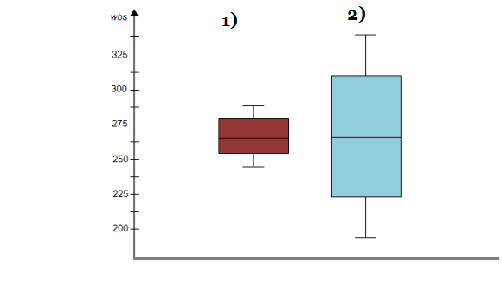
Draw an Inference from the distribution of data for Boxplot 1 with respect Boxplot 2.
Ans: The box plot 1 designed with range = 3,The second one range is = 1.5

